Tax Configuration (Menu Management):

Path : billing.petpooja.com > Menu > Menu & Discount > All In One Menu > Taxes.
outletwise_link: https://menu.petpooja.com/items/tax_list/
Steps to reach Taxes:
Step 1 : billing.petpooja.com in Steps to reach Taxes : Open your browser and go to billing.petpooja.com.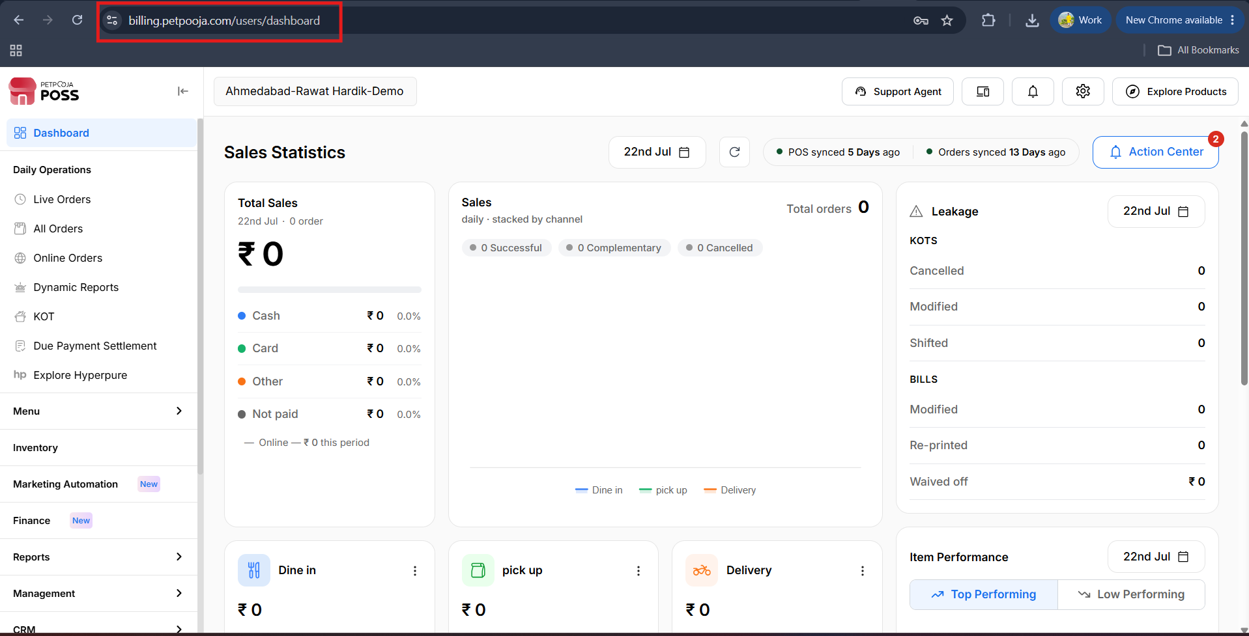
{Image Name: PetPooja Dashboard,
Description: The highlighted URL indicates that this is the billing.petpooja.com. Here is an image of Step 1 billing.petpooja.com in Steps to reach Taxes.}
Step 2 : Menu in Steps to reach Taxes : From the left-side menu, click on the Menu section.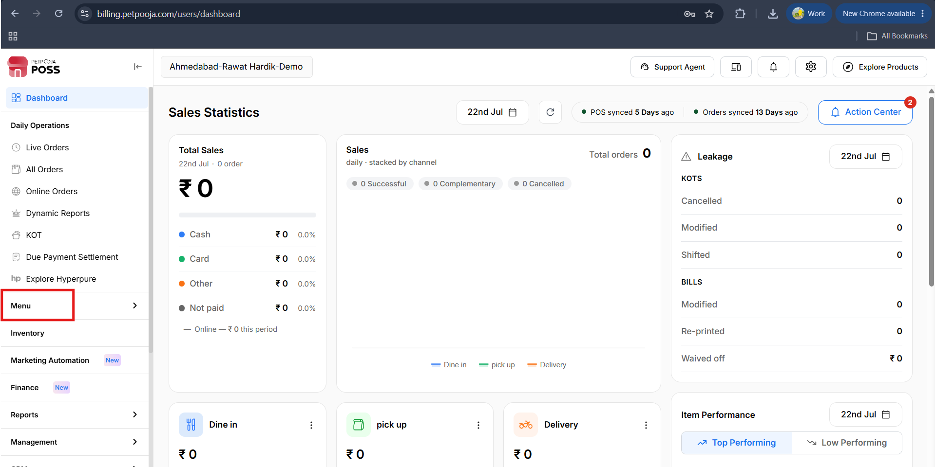
{Image Name: PetPooja Menu,
Description: The highlighted section indicates the "Menu" option on the left-side panel of the PetPooja dashboard. This allows users to manage menu items and categories. Here is an image of Step 2 Menu in Steps to reach Taxes.}

Step 3 : Menu & Discount in Steps to reach Taxes : Under Menu, select Menu & Discount.
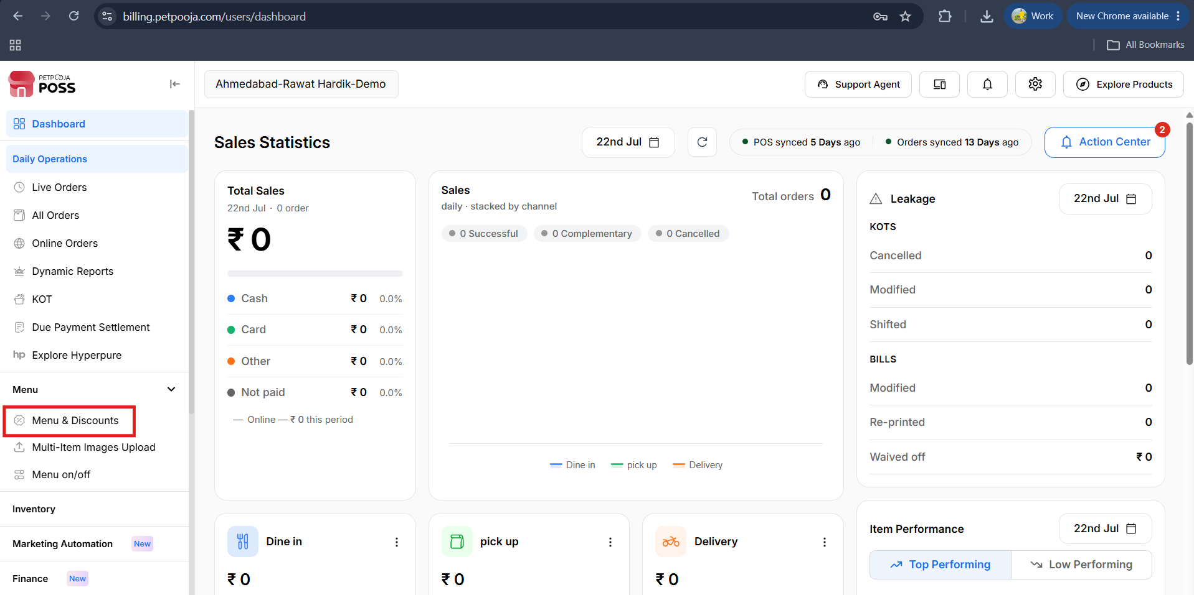
{Image Name: PetPooja Menu & Discount,
Description: The image shows the "Menu & Discount" section within the "Menu" page. This section lets users manage menu items and discounts. Here is an image of Step 3 Menu & Discount in Steps to Reach Taxes.}

Step 4 : All In One Menu in Steps to reach Taxes : Click on All In One Menu.
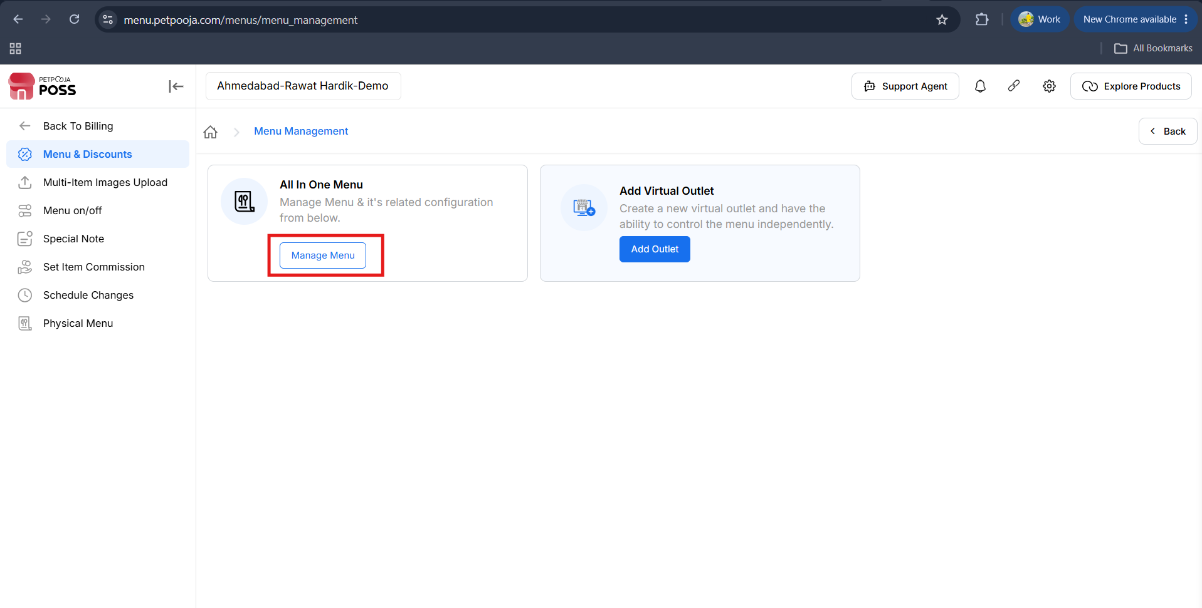
{Image Name: PetPooja All In One Menu,
Description: The highlighted section shows the "All In One Menu" option under the "Menu & Discount" tab. Here is an image of Step 4 All In One Menu in Steps to Reach Taxes.}

Step 5 : Taxes in Steps to reach Taxes : Now, select the Taxes tab to view or manage tax configurations.
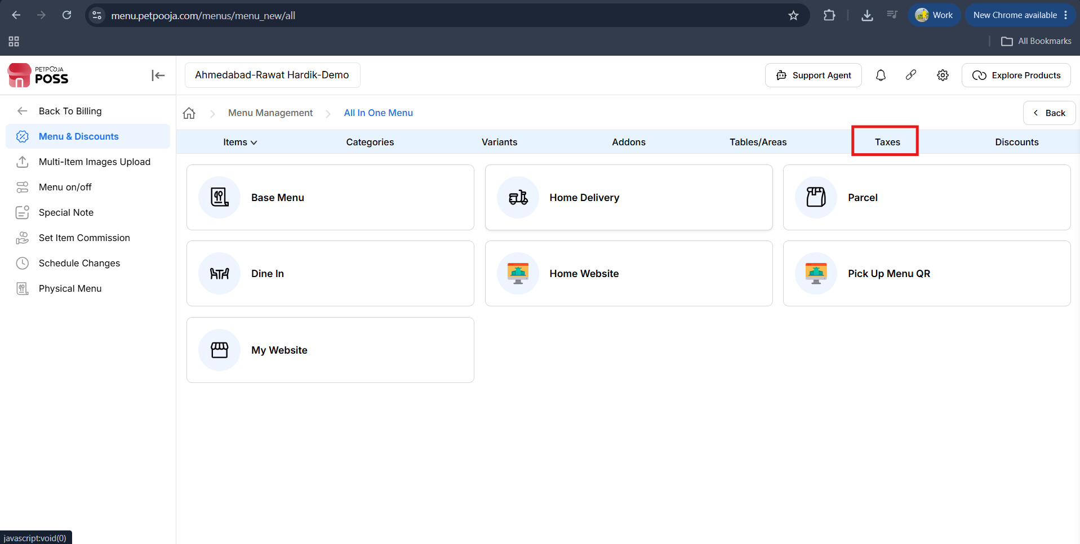
{Image Name: PetPooja Taxes,
Description: The highlighted section shows the "Taxes" option under the "All In One Menu" tab. Here is an image of Step 5 Taxes in Steps to Reach Taxes.}
(Tax Configuration) Add Tax :This button is likely used to add a new tax rule or entry into the system. It probably opens a form or popup where you can define tax details.
outletwise_link: https://menu.petpooja.com/items/tax_list/
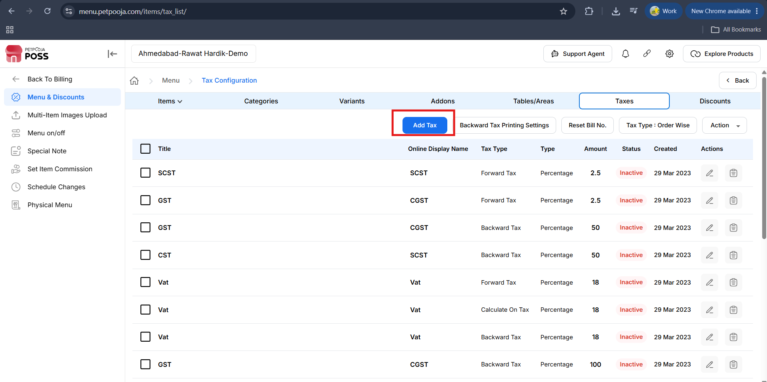
{Image Name: PetPooja – Add Tax Option,
Description: This image displays the Taxes tab under the Tax Configuration section in the PetPooja POS system. The Add Tax button is highlighted, indicating the next step to create or configure a new tax setting.}
(Add Tax) Tax Configuration Options:
outletwise_link: https://menu.petpooja.com/items/tax_list/
- (Add Tax) GST Slab: This is used for taxes in India, where you select a GST slab to apply to the items on your menu. The available GST rates are 5%, 12%, 18%, and 28%. When you choose a rate, two smaller taxes—CGST (Central GST) and SGST (State GST)—are each applied at 2.5% of the selected rate.
- (Add Tax) VAT: This tax is used for transactions outside India and is recommended for the global market. It allows you to apply VAT (Value Added Tax), which is a tax on the value added to goods and services at each stage of production or distribution. VAT is commonly used around the world and varies by country and product.
- (Add Tax) Other Taxes: This option allows you to create and manage other custom taxes, such as Cess, Corporate Tax, or any special taxes that might apply to your business. These taxes can be tailored to your needs and applied based on the specific goods, services, or operations..).
- (Add Tax) GST 5% / 12% / 18% / 28%: These are the standard GST rates in India. You can choose the rate based on the type of goods or services you are selling. For example, essential goods like food may have a lower rate, while luxury goods are taxed at a higher rate.
- (Add Tax) IGST (Integrated GST) : This tax applies to interstate transactions or imports/exports. It combines both CGST and SGST into a single tax, simplifying the taxation process for transactions between different states in India or for international trade.
(Add Tax) Tax Type* :
- (Tax Type*) Forward:With Forward Tax, the tax is added on top of the item's base price. The final price is calculated by adding the tax amount to the original item price. The base price does not include the tax. For example, if an item is priced at ₹100 with 18% Forward Tax, the tax of ₹18 is added separately, making the total price ₹118.
- (Forward) Consider this tax as mandatory. So this can't be remove even user have a rights. :
  - Check: The selected tax will be treated as mandatory and cannot be removed, even if the user has rights to modify or remove taxes.
  - Uncheck: The selected tax will not be mandatory and can be removed or modified by users with the necessary rights.
- (Tax Type*) Backward: In this method, the tax is included in the item price. The final price displayed to the customer already contains the tax. This means the price shown is the total amount, combining both the base price of the item and the tax. For example, if an item is priced at ₹100 with 18% Backward Tax, the displayed price of ₹100 includes the tax, and no additional tax is added at checkout.
- (Tax Type*) Calculate on Tax: In this type, tax is added on top of another tax. For example, Tax B is calculated on the total amount of Price + Tax A. This way, you can apply multiple taxes, with one tax being added to the amount that already includes another tax. If a tax is already added to the price, you can add another tax on top of it, making it easier to handle situations where taxes are stacked on top of each other.
(Add Tax) Order Type:
(Order Type) For Dine-in Orders:
- Check: Tick the tax option if you want to apply tax to Dine-in orders. Once saved, the system will charge tax for all Dine-in orders.
- Uncheck: Untick the tax option if you do not want to apply tax to Dine-in orders. Once saved, the system will remove tax from all Dine-in orders.
(Order Type) For Pick Up Orders:
- Check: Tick the tax option if you want to apply tax to Pick Up orders. Once saved, the system will start charging tax for Pick Up orders.
- Uncheck: Untick the tax option if you do not want to apply tax to Pick Up orders. Once saved, the system will remove tax from all Pick Up orders.
(Order Type) For Delivery Orders :
- Check: Tick the tax option if you want to apply tax to Delivery orders. Once saved, the system will charge tax for all Delivery orders.
- Uncheck: Untick the tax option if you do not want to apply tax to Delivery orders. Once saved, the system will remove tax from all Delivery orders.
(Order Type) Example:If GST is currently applied to Pick Up orders but the restaurant does not want to charge GST on Pick Up, the tax option should be unticked and saved. After this, Pick Up orders will be tax-free. If later the restaurant wants to apply 5% GST on Pick Up orders, the tax option can be ticked again and saved.
(Add Tax) Tax For order wise:
- This option allows users to select specific areas or partners where the tax applies. For example, you can apply taxes to Dine In, Takeaway, or Delivery. Additionally, taxes can be set for other listed options like third-party platforms, such as Swiggy, Zomato, or similar services. If you want to apply tax on a per-order basis, you need to select the specific outlet, such as Zomato or Swiggy, to apply the tax accordingly.
(Add Tax) Tax For Item Wise :
Description: In this option, users can choose to apply taxes on an item-by-item basis. You can either copy the tax settings from another item or manually set taxes for each item individually.
- Copy Selections From: Allows you to copy the tax settings from another item or category.
- If you want to add taxes manually, you need to select each item one by one.
Views for Manual Selection:
- Grid View: Displays all items in a table-like format, allowing for quick selection of tax settings.
- Tree View: Displays items in a hierarchical format, which is useful for more structured categorization and tax assignment.
(Add Tax) Status:
- Active: Indicates that the item, tax, or feature is currently active and being applied. This means it is enabled and functional in the system.
- Inactive: Marks the tax as Inactive, meaning it will not be applied to the items.If you want to remove the tax, it cannot be deleted, but you can make it Inactive so it will not be applied anymore.
(Add Tax) Consider This in Core Amount Calculation: Check this box only if you want to apply taxes on certain applied taxes. For example, if you want to calculate GST on the total of item price + service charge, such as 18% service charge applied on items, then mark this box. This allows the system to consider taxes on the service charge as part of the core amount calculation.
(Add Tax) SAP Code:A unique identifier or code used in SAP systems to represent a product, service, or tax item. The SAP code helps ensure accurate tracking and integration of items within the ERP (Enterprise Resource Planning) processes, enabling smooth data management and reporting.
(Add Tax) Description:This field allows you to enter additional information related to the tax or any relevant details. It is typically used to provide further clarification about the tax being applied, such as specifics about tax rates, tax application conditions, or any other relevant notes. The description entered here will be displayed for users to understand how the tax is calculated or applied in this context.
(Add Tax) Tax Title (Display on POS Billing, Bill Print & Reports):
- Description: This option allows you to define how taxes like CGST and SGST are displayed on the POS system, billing, and reports. You can customize the title to include a suffix that will be shown alongside the tax type, such as CGST@2.5 and SGST@2.5.
- Add Suffix to title : In the "Add Suffix To Title" field, you can enter a value (e.g., @2.5) to display it with the tax name on the bills and reports. For example, adding @2.5 will display CGST@2.5 and SGST@2.5 as titles on your documents.
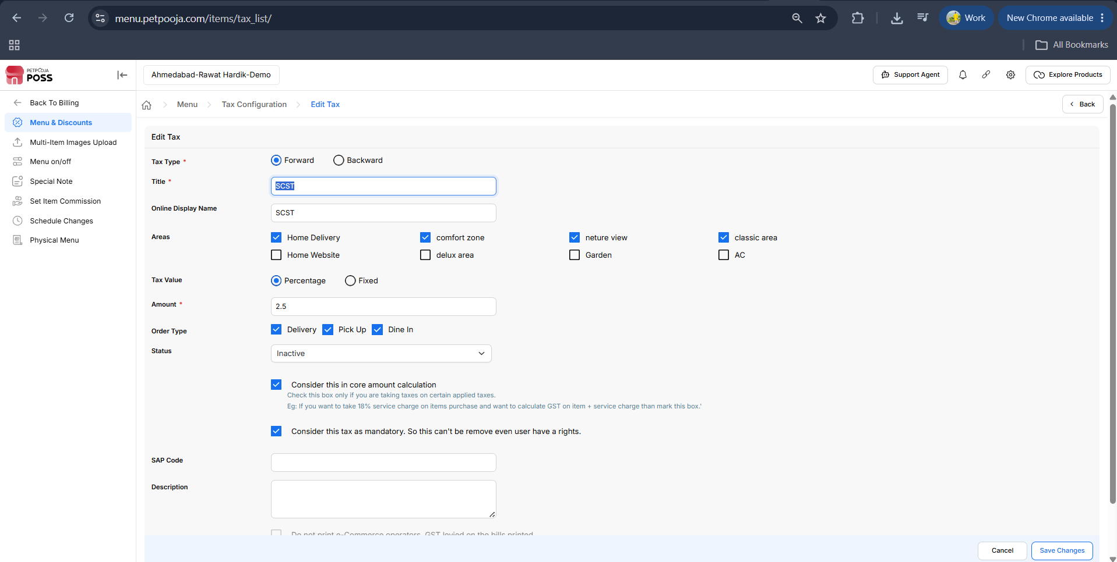
{Image Name: PetPooja – Add Tax Details Page,
Description: This screen allows users to configure tax settings by selecting GST slab, tax type, applicable areas, and order type. Users can also enter tax titles, suffixes, SAP code, and description before saving changes.}
Note (Add Tax) : If any changes are made In the Select Item type from the dashboard, manual sync is mandatory in POS/Billing Application.
Note (Add Tax) : If there are any changes to Select Item type from the dashboard for online,you have to do the menu trigger because it is mandatory.

(Add Tax) VAT :
outletwise_link: https://menu.petpooja.com/items/tax_list/
- (VAT) VAT Amount: Enter the applicable VAT percentage to be charged (e.g., 10%). This percentage will be used to calculate the VAT amount for the selected items.
- (VAT) Tax Type:
  - Forward (Tax Type) : Tax is included in the item price (final price contains tax).
  - Backward (Tax Type) : Tax is added on top of the item price (final price = item price + tax).
  - Calculate on Tax (Tax Type) : Tax is calculated on another tax (compound tax), where one tax is applied on top of another.
- (VAT) Order Type: Optionally select the applicable areas and order types where the tax should be applied.For example, Delivery, Dine In, etc. This allows the tax to be applied differently based on how the order is fulfilled.
- (VAT) Status: Set the tax status as either Active or Inactive. An Active tax will be applied to relevant transactions, while an Inactive tax will not be applied.
- (VAT) Consider This in Core Amount Calculation: Check this box only if you want to apply taxes on certain applied taxes. For example, if you want to calculate GST on the total of item price + service charge, such as 18% service charge applied on items, then mark this box. This allows the system to consider taxes on the service charge as part of the core amount calculation.
- (VAT) SAP Code:A unique identifier or code used in SAP systems to represent a product, service, or tax item. The SAP code helps ensure accurate tracking and integration of items within the ERP (Enterprise Resource Planning) processes, enabling smooth data management and reporting.
- (VAT) Description:This field allows you to enter additional information related to the tax or any relevant details. It is typically used to provide further clarification about the tax being applied, such as specifics about tax rates, tax application conditions, or any other relevant notes. The description entered here will be displayed for users to understand how the tax is calculated or applied in this context.
(VAT) Tax For order wise:
- This option allows users to select specific areas or partners where the tax applies. For example, you can apply taxes to Dine In, Takeaway, or Delivery. Additionally, taxes can be set for other listed options like third-party platforms, such as Swiggy, Zomato, or similar services. If you want to apply tax on a per-order basis, you need to select the specific outlet, such as Zomato or Swiggy, to apply the tax accordingly.
(VAT) Tax For Item Wise :
Description: In this option, users can choose to apply taxes on an item-by-item basis. You can either copy the tax settings from another item or manually set taxes for each item individually.
- Copy Selections From: Allows you to copy the tax settings from another item or category.
- If you want to add taxes manually, you need to select each item one by one.
Views for Manual Selection:
- Grid View: Displays all items in a table-like format, allowing for quick selection of tax settings.
- Tree View: Displays items in a hierarchical format, which is useful for more structured categorization and tax assignment.
- (VAT) Tax Title (Display on POS Billing, Bill Print & Reports):
  - (VAT) Description: This option allows you to define how taxes like VAT are displayed on the POS system, billing, and reports. You can customize the title to include a suffix that will appear alongside the tax type, such as VAT@10.
  - (VAT) Add Suffix To Title : In the "Add Suffix To Title" field, you can enter a value (e.g., @10) to display it with the tax name on the bills and reports. For example, adding @10 will display VAT@10 as the title.
- (VAT) Save/Cancel: Click "Save Changes" to apply or "Cancel" to discard changes.
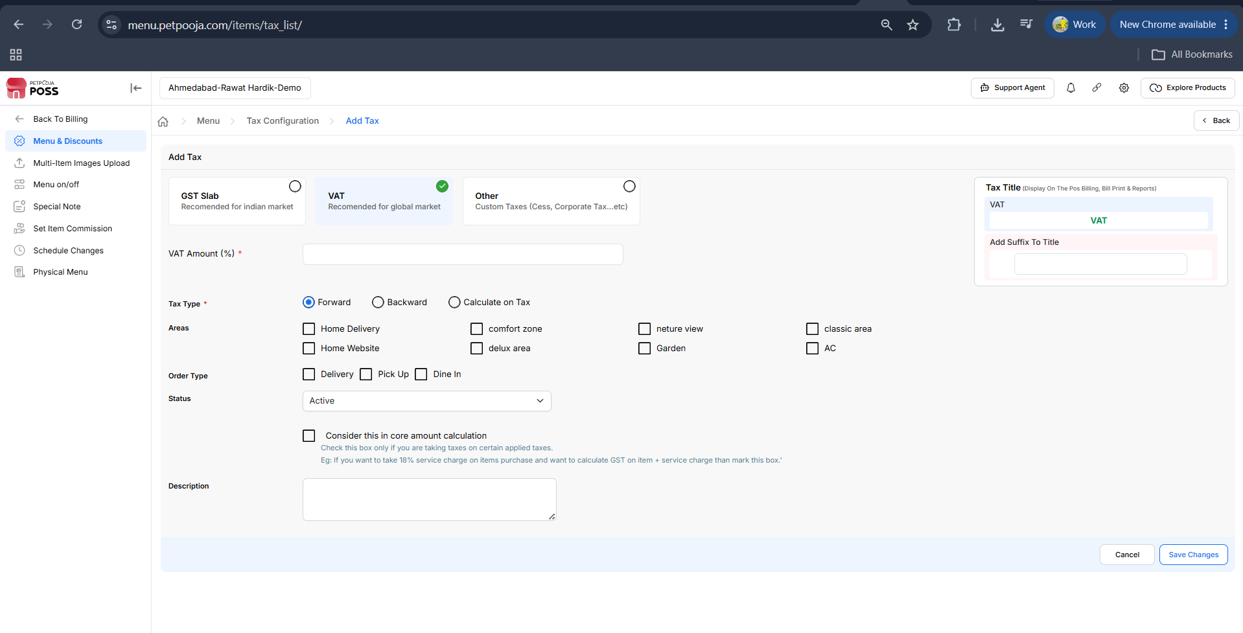
{Image Name: PetPooja – VAT Tax Configuration,
Description: This screen is used to configure VAT by specifying the VAT percentage, tax title, suffix, and applicable order types and areas. Additional fields include status, SAP code, and description before saving the setup.}
Note (VAT) : If any changes are made In the Select Item type from the dashboard, manual sync is mandatory in POS/Billing Application.
Note (VAT) : If there are any changes to Select Item type from the dashboard for online,you have to do the menu trigger because it is mandatory.

(Add Tax) Other Taxes :
outletwise_link: https://menu.petpooja.com/items/tax_list/
(Other Taxes) Tax Type:
- Description: This option allows you to select how the tax is applied to the item price. There are three main methods to apply tax:
  - Forward: In this tax type, the tax is included in the item price. The final price shown to the customer already contains the tax. The item price is displayed as the total amount, including both the base price and the tax amount.
  - Backward: In this case, the tax is added on top of the item price. The final price is calculated by adding the tax to the original item price. The item price does not include the tax, and the tax is added separately during checkout.
  - Calculate on Tax: This option allows tax to be calculated on another tax, also known as a compound tax. For example, Tax B can be applied on the total of Price + Tax A. This method is used when one tax is applied on the amount after another tax has been applied.
(Other Taxes) Title:
- Description: This option allows you to enter the name of the tax, which will be displayed in reports and on the billing documents. The title will identify the type of tax being applied, such as CGST, SGST, VAT, or other custom taxes. This ensures clarity in understanding which tax is applied to the items or services in your system.
(Other Taxes) Online Display Name:
- Description: This option allows you to enter the display name that will appear online, such as on your website or mobile app. It is used to represent the tax applied to items in a user-friendly format for online customers. This ensures that the tax is clearly displayed to the customer when they are viewing products or services online.
(Other Taxes) Tax Value:
- Description: This option allows you to choose how the tax is calculated—either as a Percentage of the item price or as a Fixed amount. This ensures flexibility in how the tax is applied based on your business requirements.
- Percentage: The tax is calculated as a percentage of the item price. For example, if the item price is ₹100 and the tax rate is 18%, the tax will be ₹18, making the total price ₹118.
- Fixed: The tax is a fixed amount, regardless of the item price. For example, if the fixed tax is ₹10, it will be added to any item price, whether it’s ₹50 or ₹500.
(Other Taxes) Amount:
- Description: This option allows you to enter the value of the tax based on the selected tax type.
  - If Percentage is selected, this field represents the percentage rate of the tax (e.g., 18%).
  - If Fixed is selected, this field represents the fixed tax amount (e.g., 50). This value will be added to the item price regardless of its cost.
(Other Taxes) Order Type:
- Description: This option allows you to select the types of orders where the tax will be applied. You can choose from different order types, ensuring that the correct tax is applied based on the method of order.
  - Delivery: Tax is applied to orders placed for delivery. This ensures that customers who choose delivery are charged the appropriate tax.
  - Pick Up: Tax is applied to pick-up orders, where customers order online or over the phone and pick up their items in person.
  - Dine In: Tax is applied to dine-in orders, where customers eat their meal at the restaurant or establishment.
(Other Taxes) Status:
- Description: This option allows you to set the tax status as either Active or Inactive, determining whether the tax is applied to orders or not.
  - Active: The tax is applied to orders, and customers will be charged the specified tax rate based on the selected tax type.
  - Inactive: The tax is not applied to orders. This option can be used to temporarily disable the tax without removing it from the system.
(Other Taxes) Consider this in Core Amount Calculation:
- Description: Check this box if you are applying taxes on certain applied taxes.
  - For example, if you are applying an 18% service charge on items purchased and want to calculate GST on the combined total of the item price and the service charge, you should mark this box.
(Other Taxes) SAP Code:
- Description: Enter the SAP code for internal reference or ERP integration. This code is used to track the tax in your business systems, allowing for easier management and reporting. The SAP code helps link the tax to specific records in your Enterprise Resource Planning (ERP) system, ensuring seamless integration and data flow across platforms.
(Other Taxes) Description:
- Description: Enter a description for the tax, which can be used for internal tracking or reference. This helps in identifying the tax type more clearly in your system or reports.
(Other Taxes) Tax For order wise:
- This option allows users to select specific areas or partners where the tax applies. For example, you can apply taxes to Dine In, Takeaway, or Delivery. Additionally, taxes can be set for other listed options like third-party platforms, such as Swiggy, Zomato, or similar services. If you want to apply tax on a per-order basis, you need to select the specific outlet, such as Zomato or Swiggy, to apply the tax accordingly.
(Other Taxes) Tax For Item Wise :
- Description: In this option, users can choose to apply taxes on an item-by-item basis. You can either copy the tax settings from another item or manually set taxes for each item individually.
- Copy Selections From: Allows you to copy the tax settings from another item or category.
- If you want to add taxes manually, you need to select each item one by one.
(Other Taxes) Views for Manual Selection:
- Grid View: Displays all items in a table-like format, allowing for quick selection of tax settings.
- Tree View: Displays items in a hierarchical format, which is useful for more structured categorization and tax assignment.
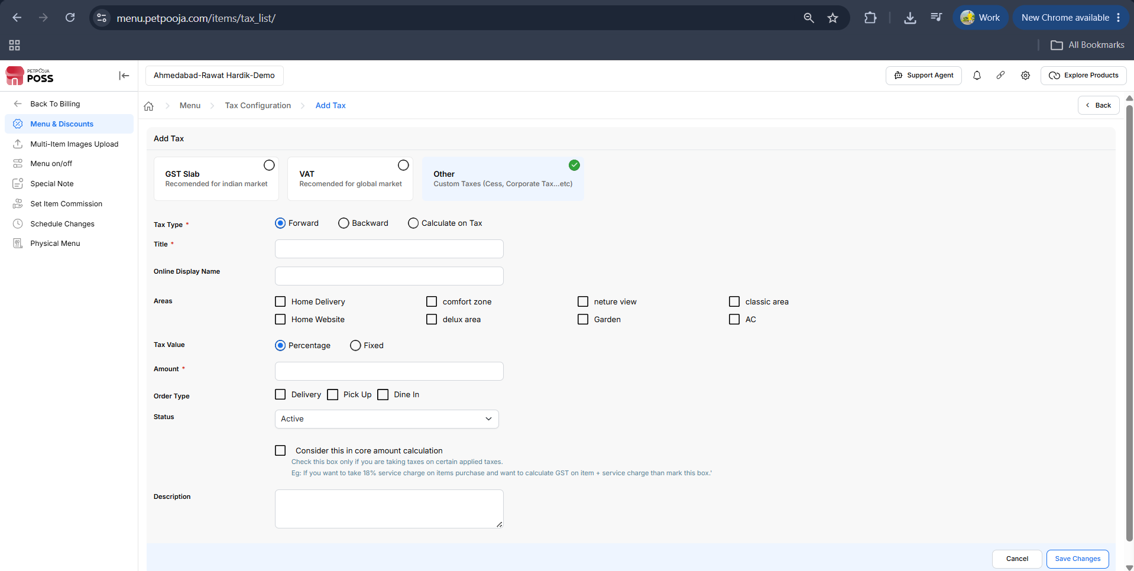
{Image Name: PetPooja – Other Tax Configuration,
Description: This screen is used to configure custom taxes (like Cess or Corporate Tax) by entering the tax title, value (percentage or fixed), applicable areas, order types, and other details before saving the changes.}
Note (Other Taxes) : If any changes are made In the Select Item type from the dashboard, manual sync is mandatory in POS/Billing Application.
Note (Other Taxes) : If there are any changes to Select Item type from the dashboard for online,you have to do the menu trigger because it is mandatory.

(Tax Configuration) Backward Tax Printing Settings: To configure Backward Tax Printing Settings, you need to click on the option. This will allow you to customize how the tax is printed on receipts or invoices when it is applied as Backward Tax (where the tax is added on top of the item price).

outletwise_link: https://menu.petpooja.com/items/tax_list/
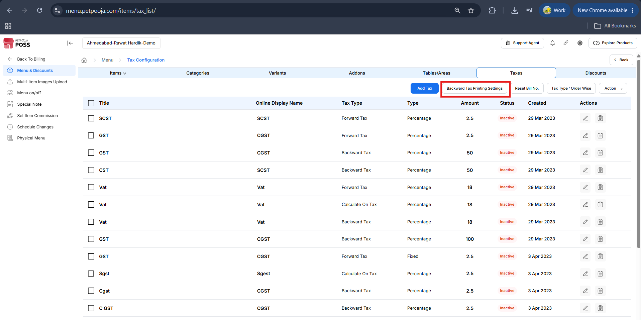
{Image Name: PetPooja – Backward Tax Printing Settings,
Description: This screen displays a list of configured taxes with details like type, percentage, and status. It also includes options to add a new tax or modify backward tax printing settings.}
- Individual Item Price will be shown (without backward tax) on printed bill:
- Description: This option will display the price of each item without the backward tax included on the printed bill. The individual item prices will reflect the base price of the item, and the tax will not be shown as part of the price.
- Individual Item Price will be shown (including backward tax) on printed bill:
- Description: This option will display the price of each item with the backward tax included on the printed bill. The individual item prices will reflect the total amount, including both the item price and the tax.
- Show backward tax on printed bill:
- Description: This option ensures that the backward tax amount is explicitly shown separately on the printed bill, even if the individual item prices are shown without tax or with tax included.
- Action Buttons (Backward Tax Printing Settings) :
- Cancel: Discards changes and exits the settings.
- Save Changes: Applies the selected settings.
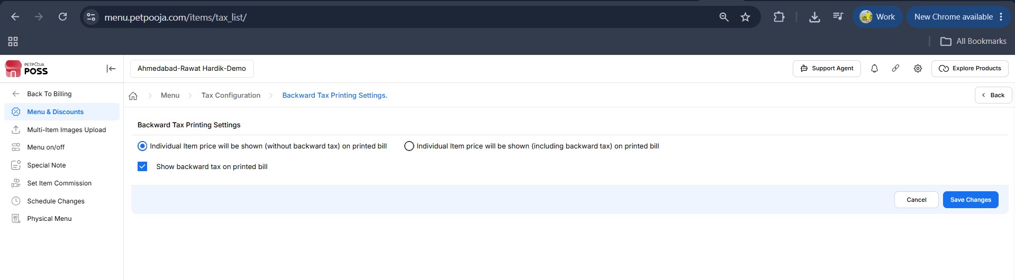
{Image Name: Backward Tax Printing Settings,
Description: This screen allows users to configure how item prices and backward tax appear on printed bills in Petpooja POS. Users can choose to display item prices with or without backward tax and enable backward tax visibility on the bill.}
Note (Backward Tax Printing Settings) : If any changes are made In the Select Item type from the dashboard, manual sync is mandatory in POS/Billing Application.
Note (Backward Tax Printing Settings) : If there are any changes to Select Item type from the dashboard for online,you have to do the menu trigger because it is mandatory.

(Tax Configuration) Export Consolidated Tax

Overview : This option allows you to export consolidated tax information for items across various areas. You can select multiple areas to export, but the system limits the selection to a maximum of 15 areas. This helps to gather tax data for different areas or outlets and export it in a single file for easier analysis.
(Export Consolidated Tax) Export Consolidated Item Wise Tax :
(Export Consolidated Item Wise Tax) Select Area(s) You Want to Export in CSV Sheet:
- (Export Consolidated Item Wise Tax) Description: A list of available areas is displayed, and you can choose which ones you want to include in the export. The areas listed may include options like General, Garden, Non AC, Home Delivery, Swiggy, Pick Up, Foodpanda_tests, etc.
- (Export Consolidated Item Wise Tax) Additional Info: After selecting the desired areas, click "Export" to download the data in a CSV format. If you wish to cancel the operation, click "Close".

(Tax Configuration) Item / Order wise Tax Settings : This option allows you to define how taxes should be applied in your outlet. If you want to apply tax item-wise, you can enable this setting and assign different tax rates to individual items. In the same way, if you want to apply tax order-wise, you need to select the order-wise option and save it. This ensures that taxes are calculated either per item or on the total bill, based on your selection.
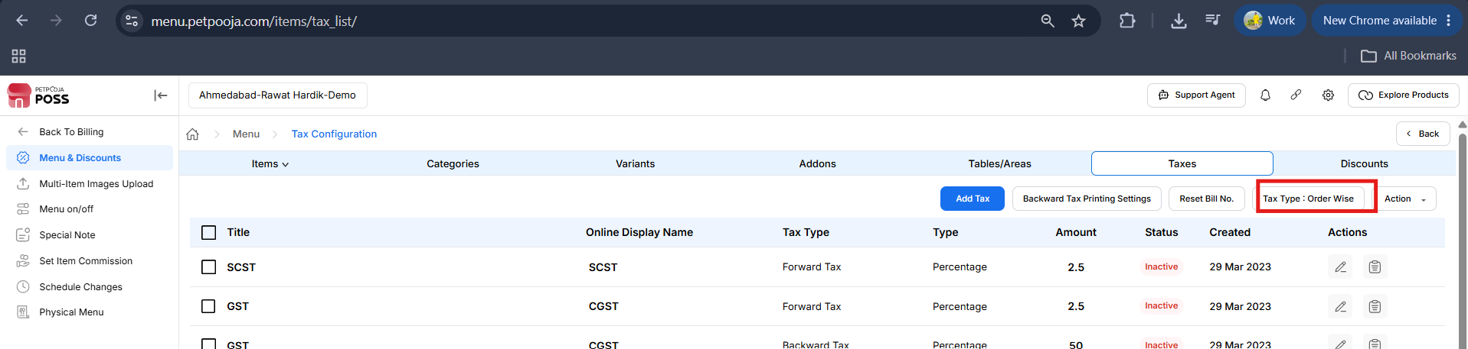
{Image Name: Tax Type Selection - Order Wise/Itemwise,
Description: This image highlights the "Tax Type: Order Wise" setting under the Taxes tab in the Tax Configuration section. This option applies the selected tax to the entire order rather than individual items.}
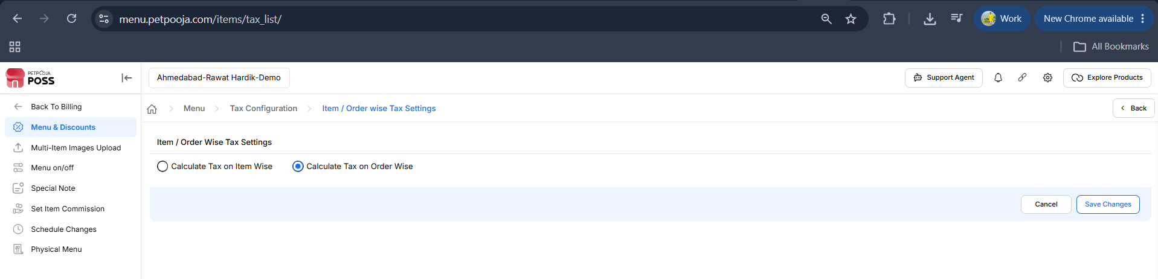
{Image Name: Item / Order Wise Tax Settings,
Description: A settings page for configuring tax calculation methods, where users can choose between calculating tax on individual items or on the entire order. The page features radio buttons for selecting the calculation method, with a red error notification above the buttons and a "Save Changes" button at the bottom.}
  - Calculate Tax on Item Wise: If you select item-wise tax, each item's price will have tax applied individually based on its price.
  - Calculate Tax on Order Wise : If you select order-wise tax, the total price of the order will have tax applied as a percentage of the whole, instead of individual items.
Note (Item / Order wise Tax Settings) : If any changes are made In the Select Item type from the dashboard, manual sync is mandatory in POS/Billing Application.
Note (Item / Order wise Tax Settings) : If there are any changes to Select Item type from the dashboard for online,you have to do the menu trigger because it is mandatory.
(Tax Configuration) Action: This menu allows the user to perform status changes on selected tax configurations.
outletwise_link: https://menu.petpooja.com/items/tax_list/
- Active: Marks the tax as Active, meaning it will be applied to the items.
- Inactive: Marks the tax as Inactive, meaning it will not be applied to the items.If you want to remove the tax, it cannot be deleted, but you can make it Inactive so it will not be applied anymore.
- Note : You must select at least one tax before you can perform any of these actions (Active, Inactive).

(Tax Configuration) Actions :
outletwise_link: https://menu.petpooja.com/items/tax_list/
- (Action) Edit : Represented by a pencil icon, this function allows you to modify or make changes to a specific item or record. It is used when you need to update the details or settings of an item or entry.
- (Action) Identify Export/Import : You can export a list of taxes in CSV format for reporting or import a CSV file to update the tax information in your system.
- (Action) Show Changes : This feature allows you to view the modifications or differences made to a specific record. It helps you track changes over time, ensuring transparency and accountability in the system.

(Tax Configuration) Copy Area to Area :
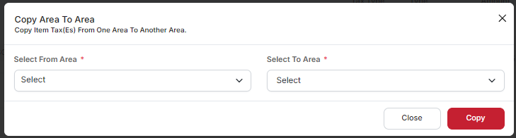
{Image Name: Copy Area To Area,
Description: A modal window to copy item tax settings from one area to another. The form includes two dropdown menus for selecting the source ("Select From Area") and the destination ("Select To Area") areas. There are two buttons at the bottom: "Close" and "Copy," with the "Copy" button highlighted in red.}
(Copy Area to Area) Select From Area Dropdown: This dropdown allows the user to select the area from which the tax information will be copied. You can choose the source area whose tax data you want to transfer.
(Copy Area to Area) Select To Area Dropdown: This dropdown allows the user to select the destination area where the tax information will be copied. You can choose the target area where you want the tax data to be applied.
(Copy Area to Area) Copy Button: After selecting both the From Area and To Area, click this button to initiate the copying process. This will transfer the tax information from the selected source area to the destination area.
(Copy Area to Area) Close Button: If you no longer wish to proceed with the action, clicking this button will close the dialog box without making any changes to the areas or tax information.
Note: To change the tax, follow the same process. Simply uncheck the currently applied tax and select the tax that you want to apply.

Note (Copy Area to Area) : If any changes are made In the Select Item type from the dashboard, manual sync is mandatory in POS/Billing Application.
Note (Copy Area to Area) : If there are any changes to Select Item type from the dashboard for online,you have to do the menu trigger because it is mandatory.
Note: If you want to make all taxes inactive at once, you can do that as well. Simply select the checkbox next to the item names, then click the Action button at the top-right and choose Inactive. Confirm the action to apply the changes.
After that, perform a Manual Sync on the Billing POS (Main Server). If you want the changes to reflect on online platforms, you must perform a Menu Trigger.
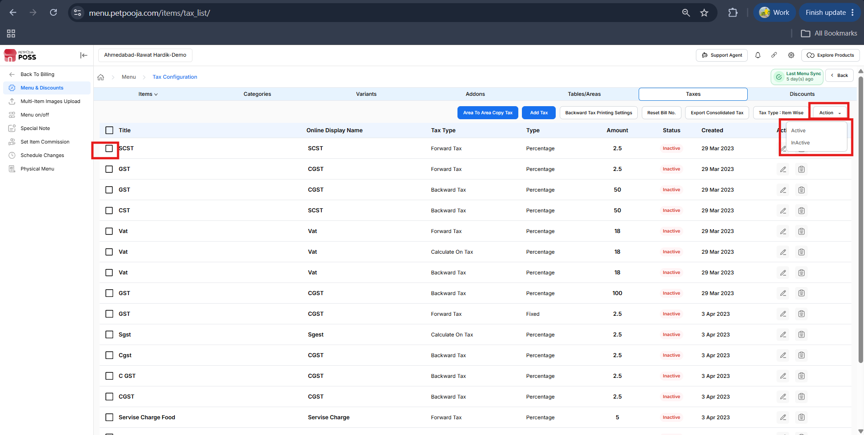
{ Image Name: Bulk Activate/Deactivate Taxes
Description ; The highlighted checkboxes allow you to select one or multiple tax entries. After selecting the required taxes, click the Action button in the top-right corner and choose Active or InActive to update the status of all selected taxes at once. Confirm the action to apply the changes. }

